Does Fitness Protect Against Heart Failure
The prevalence of Heart failure (HF) has been increasing steadily over the last three decades. Approximately 5.7 million people in the United States have HF, with a projected increase to more than 8 million people by 2030. This increase is attributable to several factors, including an aging population, obesity and recent advances in the treatment of cardiovascular disease (CVD), leading to increased survival following an acute cardiac event.
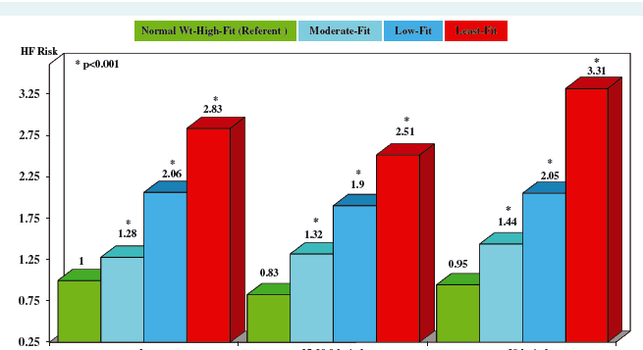
There is also evidence that a sedentary lifestyle or poor exercise capacity increase the risk of developing heart failure and premature death. If so, does increased fitness protect against HF regardless of body weight? This was addressed in a study of over 20,250 US Veterans conducted by lead author, Peter Kokkinos, Director of the Exercise Core of the Nutrition, Exercise and Metabolism Center and faculty in the Department of Kinesiology and Health. In this study, fitness of each participant was assessed by an exercise treadmill and followed for 13.6 ±7.7 years. During that period, 2,979 participants developed heart failure. The rate of heart failure among participants with different BMI and fitness levels is illustrated in the graph. The data show that within each BMI category the HF cases increased as fitness decreased. Said another way, the increase in HF rate is driven by poor fitness and not BMI, as the increased risk is very similar within fitness category regardless of BMI.
Normal Weight Overweight Obese
European Journal of Heart Failure, 2019; 21, 436–444 doi:10.1002/ejhf.1433

